ØØ Explanation :
- Get the number in the accumulator from register B.
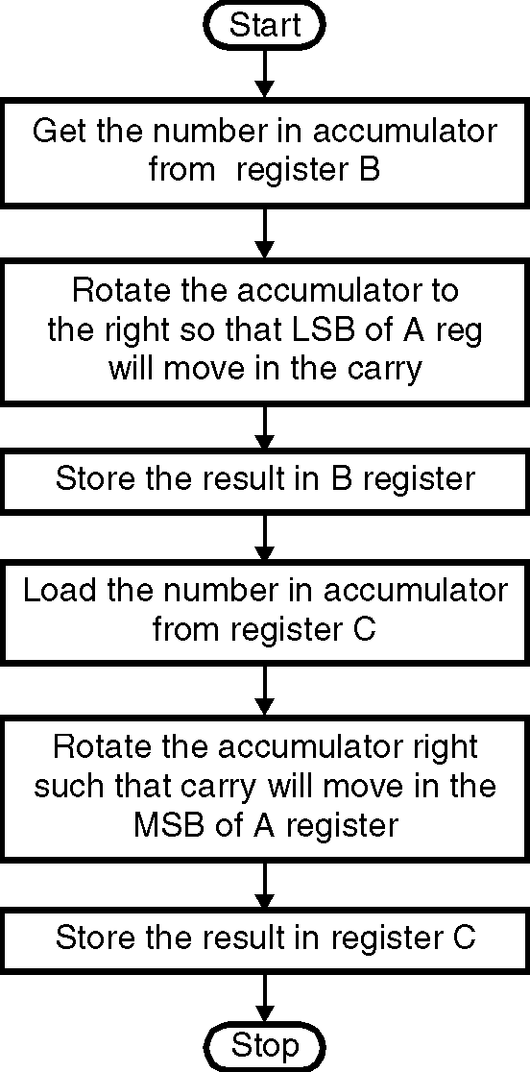
- Rotate the number 1 time to the right
- Store the shifted number back in register B
- Get the number in the accumulator from register C.
- Rotate the number 1 time to the right
- Store the shifted number back in register C
ØØ Algorithm :
Step I : Get the number the in the accumulator
from register B.
Step II : Rotate the number 1 time to the right.
Step III : Store the result in register B.
Step IV : Get the number the in the accumulator
from register C.
Step V : Rotate the number 1 times to the right.
Step VI : Store the result in register C.
Step VII : Stop
ØØ Flowchart : Refer flowchart 27.
ØØ Program :
Instruction Comment
MOV A,B ; Load the number in register A
RAR ; Rotate the number 1 time Flowchart 27
; to the right
MOV B,A ; Store the shifted number
MOV A,C ; Load the number in register A
RAR ; Rotate the number 1 time to the right
MOV C,A ; Store the shifted number
HLT ; Terminate program execution

